Tutorial – 2

- Write a C# Sharp program that stores elements in an array and prints them.
namespace Tutorial___Array
{
internal class T1
{
public static void t1()
{
int[] arr = {10,20,30,40,50,60};

foreach(int i in arr)
{
Console.WriteLine(i);
}
}
}
}
Output:
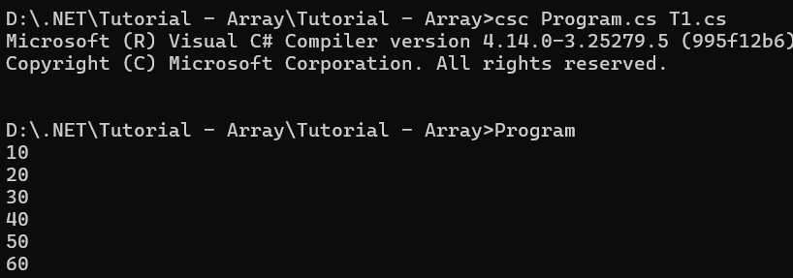

- Write a program of sorting an array. Declare single dimensional array and accept 5 integer values from the user. Then sort the input in ascending order and display output.
namespace Tutorial___Array
{
internal class T2
{
public static void t2()
{
int[] arr = new int[5];
string str;
int temp;
for (int i = 0; i < 5; i++)
{
Console.Write("Enter value " + (i+1) + " : ");
str = Console.ReadLine();
arr[i] = Convert.ToInt32(str);
Console.WriteLine();
}

for(int i = 0; i < arr.Length; i++)
{
for(int j = i; j < arr.Length; j++)
{
if(arr[i] >= arr[j])
{
temp = arr[i];
arr[i] = arr[j];
arr[j] = temp;
}
}
}

for(int i = 0; i < 5; i++)
{
Console.WriteLine("Arr value "+(i+1)+" : " + arr[i]);
}
}
}
}
Output:
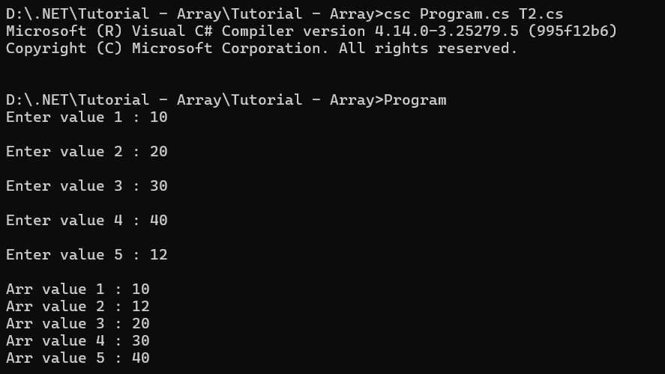
- Write a C# Sharp program to read n values in an array and display them in reverse order.
namespace Tutorial___Array
{
internal class T3
{
public static void t3()
{
Console.WriteLine("How many value you want to enter in array?");
String str = Console.ReadLine();
int n = Convert.ToInt32(str);

int[] arr = new int[n];

for(int i = 0; i < n; i++)
{
Console.Write("\nEnter value " + (i + 1) + " : ");
str = Console.ReadLine();
arr[i] = Convert.ToInt32(str);
}

for (int i = arr.Length; i > 0; i--)
{
Console.WriteLine(" "+arr[(i-1)]);
}

}
}
}
Output:
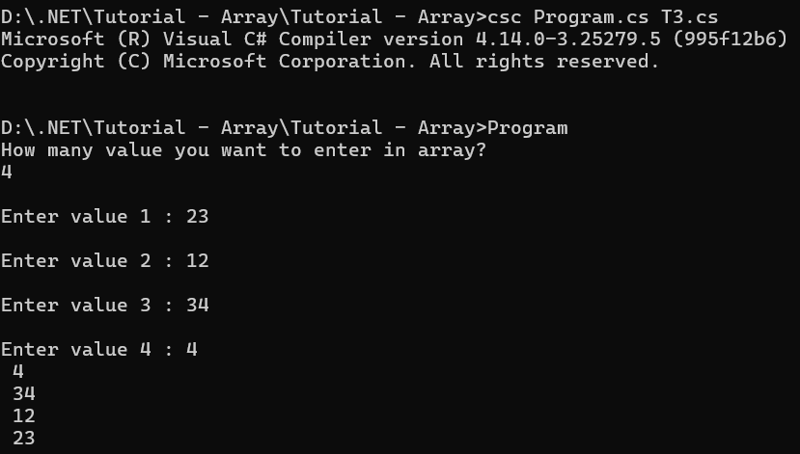
- Write a C# Sharp program to copy the elements of one array into another array.
namespace Tutorial___Array
{
internal class T4
{
public static void t4()
{
int[] arr1 = { 4, 32, 12, 67, 234, 32 };
int[] arr2 = new int[arr1.Length];

for(int i = 0; i < arr1.Length; i++)
{
arr2[i] = arr1[i];
}

Console.WriteLine("Copied Array : ");
for(int i = 0; i < arr2.Length; i++)
{
Console.WriteLine(arr2[i]);
}
}
}
}
Output:
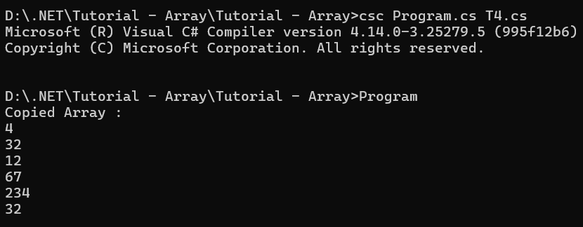

- Write a C# Sharp program to count duplicate elements in an array.
namespace Tutorial___Array
{
internal class T5
{
public static void t5()
{
int[] arr = {1,1,1,2,2};
int count = 0;
for(int i = 0; i < arr.Length; i++)
{
for(int j = i; j < arr.Length; j++)
{
if (arr[i] == arr[j])
{
count++;
}
}
}
Console.WriteLine("Duplicate Element : "+ count);
}
}
}
Output:
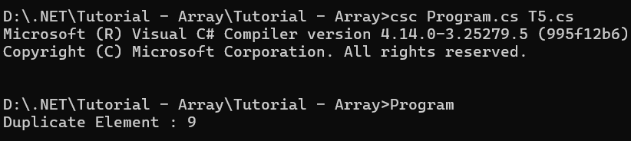

- Write a C# Sharp program to find the maximum and minimum elements in an array.
namespace Tutorial___Array
{
internal class T6
{
public static void t6()
{
int[] arr = {23,1,45,34,2,56,5};
int temp = 0;

for (int i = 0; i < arr.Length; i++)
{
for (int j = i; j < arr.Length; j++)
{
if (arr[i] >= arr[j])
{
temp = arr[i];
arr[i] = arr[j];
arr[j] = temp;
}
}
}
Console.WriteLine("Minimum value is : " + arr[0]);

Console.WriteLine("Maximum value is : " + arr[arr.Length - 1]);
}
}
}
Output:
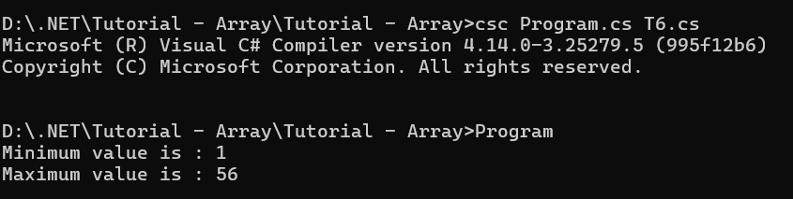
- Write a program in C# Sharp to separate odd and even integers into separate arrays.
namespace Tutorial___Array
{
internal class T7
{
public static void t7()
{
int[] arr = {12,23,45,23,45,67,4,34,2,67,89};
int[] oddArr = new int[arr.Length];
int[] evenArr = new int[arr.Length];

int evenCount = 0, oddCount = 0;

for(int i = 0; i < arr.Length; i++)
{
if (arr[i] % 2 == 0)
{
evenArr[evenCount] = arr[i];
evenCount++;
}
else
{
oddArr[oddCount] = arr[i];
oddCount++;
}
}

Console.WriteLine("Even Numbers:");
foreach (var num in evenArr)
{
if (num != 0) // To avoid printing uninitialized elements
{
Console.Write(num + " ");
}
}
Console.WriteLine("\nOdd Numbers:");
foreach (var num in oddArr)
{
if (num != 0) // To avoid printing uninitialized elements
{
Console.Write(num + " ");
}
}
}
}
}
Output:
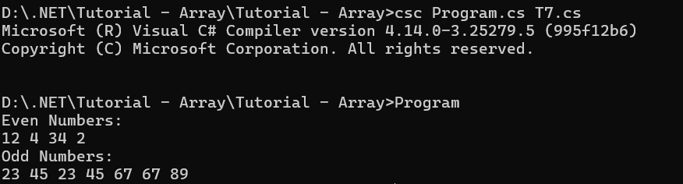

- Write a C# Sharp program to sort array elements in descending order.
namespace Tutorial___Array
{
internal class T8
{
public static void t8()
{
int[] arr = new int[5];
string str;
int temp;
for (int i = 0; i < 5; i++)
{
Console.Write("Enter value " + (i + 1) + " : ");
str = Console.ReadLine();
arr[i] = Convert.ToInt32(str);
Console.WriteLine();
}

for (int i = 0; i < arr.Length; i++)
{
for (int j = i; j < arr.Length; j++)
{
if (arr[i] <= arr[j])
{
temp = arr[i];
arr[i] = arr[j];
arr[j] = temp;
}
}
}

for (int i = 0; i < 5; i++)
{
Console.WriteLine("Arr value " + (i + 1) + " : " + arr[i]);
}
}
}
}
Output:
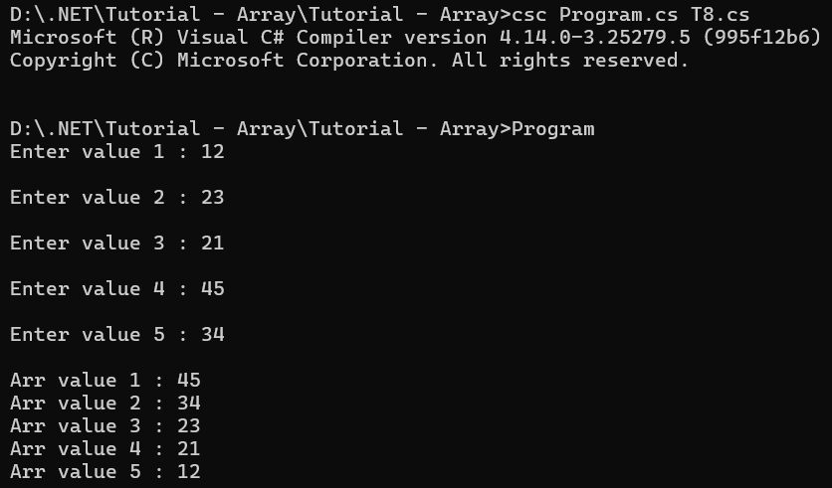

- Write a C# Sharp program to delete an element at the desired position from an array.
namespace Tutorial___Array
{
internal class T9
{
public static void t9()
{
int[] arr = new int[5];
string str;
int temp;
for (int i = 0; i < 5; i++)
{
Console.Write("Enter value " + (i + 1) + " : ");
str = Console.ReadLine();
arr[i] = Convert.ToInt32(str);
Console.WriteLine();
}

Console.WriteLine("Provide an elemen to delete : ");
string deleteStr = Console.ReadLine();

for (int i = 0; i < arr.Length; i++)
{
if(Convert.ToInt32(deleteStr) == arr[i])
{
arr[i] = 0;
}
}

for (int i = 0; i < 5; i++)
{
Console.WriteLine("Arr value " + (i + 1) + " : " + arr[i]);
}
}
}
}
Output:
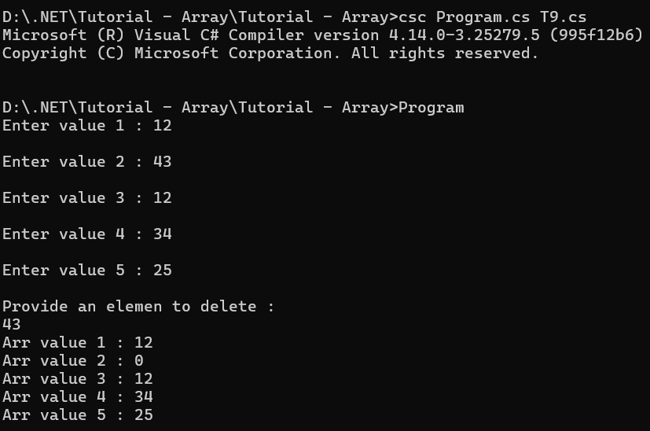

10. Write a C# Sharp program for adding two matrices of the same size.
namespace Tutorial___Array
{
internal class T10
{
public static void t10()
{

int rows, cols;

Console.Write("Enter the number of rows: ");
rows = int.Parse(Console.ReadLine());
Console.Write("Enter the number of columns: ");
cols = int.Parse(Console.ReadLine());

int[,] matrix1 = new int[rows, cols];
int[,] matrix2 = new int[rows, cols];
int[,] sumMatrix = new int[rows, cols];

Console.WriteLine("Enter elements for the first matrix:");
InputMatrixElements(matrix1);

Console.WriteLine("Enter elements for the second matrix:");
InputMatrixElements(matrix2);

// Add the matrices
for (int i = 0; i < rows; i++)
{
for (int j = 0; j < cols; j++)
{
sumMatrix[i, j] = matrix1[i, j] + matrix2[i, j];
}
}

// Display the sum matrix
Console.WriteLine("Sum of the matrices:");
DisplayMatrix(sumMatrix);
}

// Method to input elements into a matrix
static void InputMatrixElements(int[,] matrix)
{
int rows = matrix.GetLength(0);
int cols = matrix.GetLength(1);

for (int i = 0; i < rows; i++)
{
for (int j = 0; j < cols; j++)
{
Console.Write($"Element at row {i + 1}, column {j + 1}: ");
matrix[i, j] = int.Parse(Console.ReadLine());
}
}
}

// Method to display a matrix
static void DisplayMatrix(int[,] matrix)
{
int rows = matrix.GetLength(0);
int cols = matrix.GetLength(1);

for (int i = 0; i < rows; i++)
{
for (int j = 0; j < cols; j++)
{
Console.Write(matrix[i, j] + " ");
}
Console.WriteLine();
}
}
}
}
Output:
